Protocol n. 1 del 02/03/2019
This document is the technical report that analyzes, describes and certifies the tests and measurements carried out on the drone according to the CE standard and according to the best practice conducted by DPM Elettronica for tests that are not yet regulated.
The manual that accompanies the DronesBench certificate explains in detail the tools, methods and calculations used during the tests.
DronesBench certificate V.1.0
DPM Elettronica
www.dronesbench.it

Introduction
The purpose of this document is to objectively describe the technical characteristics of the drone in multiple operating conditions in order to verify if it is suitable for marketing in the reference countries and to calculate with accuracy the class and operational area according to the most recent European regulations.
It also incorporates the use of existing legislation for electromagnetic compatibility and is proposed as a best practice with regard to the rules and standards not yet present.
The manual that accompanies the DronesBench certificate explains in detail the tools, methods and calculations used during the tests.
Always be careful to match the version of the manual to the same version of the certificate.

Customer ID
This technical report was commissioned VAT number 02422080719 by DPM Elettronica srl in via SANT’ALFONSO DE ’LIGUORI 61 represented by Ing. Mauro Pompetti born in FORLI on 08/28/1961 and resident in FOGGIA tax code PMPMRA61M28D704S in the figure of ADMINISTRATOR.

Environment, operators and spectators
The tests began on 02/04/2019 at 10:14 am with a temperature of 26 ° C and with a pressure of 1008 mbar and with a humidity of 30%.
The test site is the DPM Elettronica test laboratory, in via Sant’Alfonso de ’Liguori, 61 Foggia.
They are present during the tests:

Nominative | Fiscal Code | Role | Signature
GIANMARCO D’URSO | DRSGMR91M24D643B | MISURISTA

Drone features
The drone is named Kit M1 S600
Diameter between rotor axes [mm] | 595 | Minimum battery voltage [V] | 11.1 [3S]
Frame diameter [mm] | 655 | Battery capacity [mAh] | 4400
Frame width [mm] | 22 | Propellers lead [in] | 5.5
Propellers diameter [mm] | 390 | Drone battery C | 30C
Alleged payload [g] | 2000 | Battery weight [g] | 293
Drone weight (with battery and maximum equipment) [g] | 1739 | Number of propellers | 4

Components | Model e version
Frame | S600 CUSTOM
Imu | PIXHAWK 2.4.8
Esc | JMT 40A BRUSHLESS ESC
Motors | HYD 3508 700KV 198W
Propellers | 15x5.5 3K CARBON FIBER
Receiver | AT9-R9DS 2.4GHz
Transmitter | AT9S 2.4GHz
GPS | NEO-7M 7M GPS MODULE WITH COMPASS
Radio control | RADIOLINK AT9S 10CH
Video transmitter | -

Front and side photo
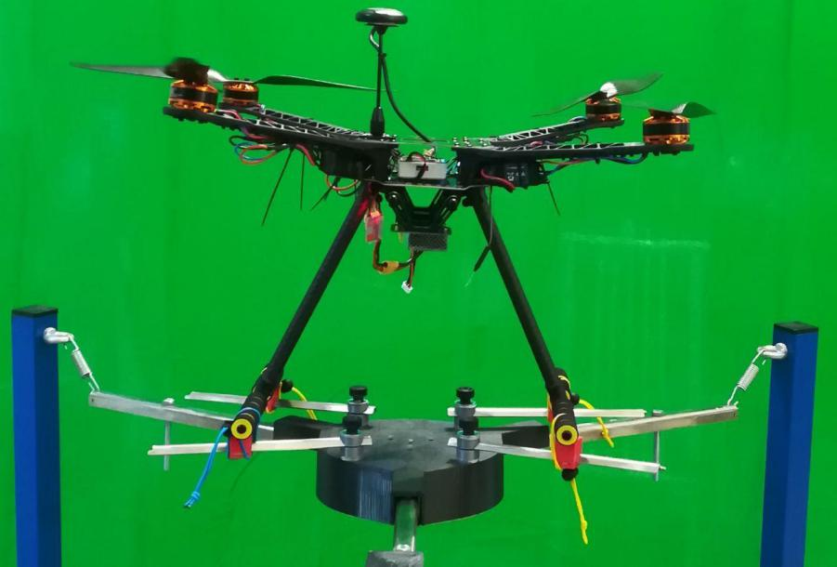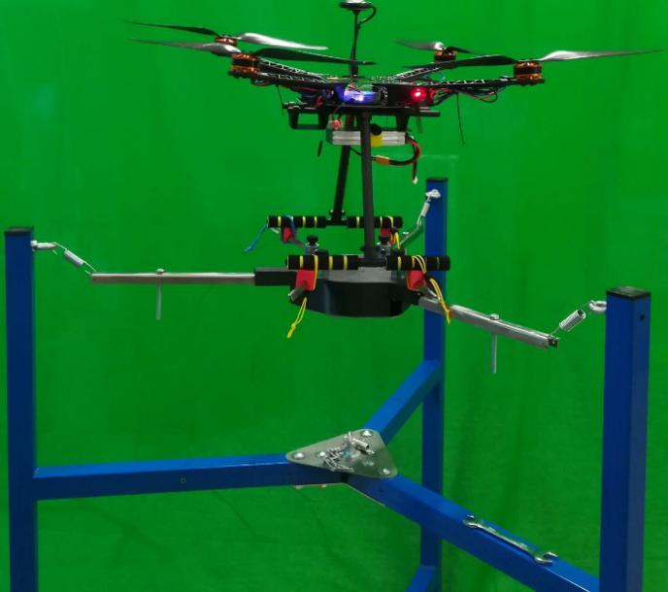

Photo from the top and from the maximum pitch angle

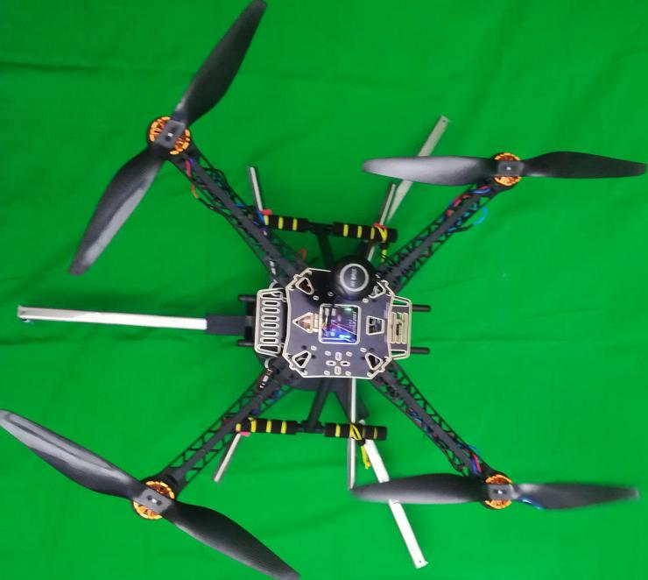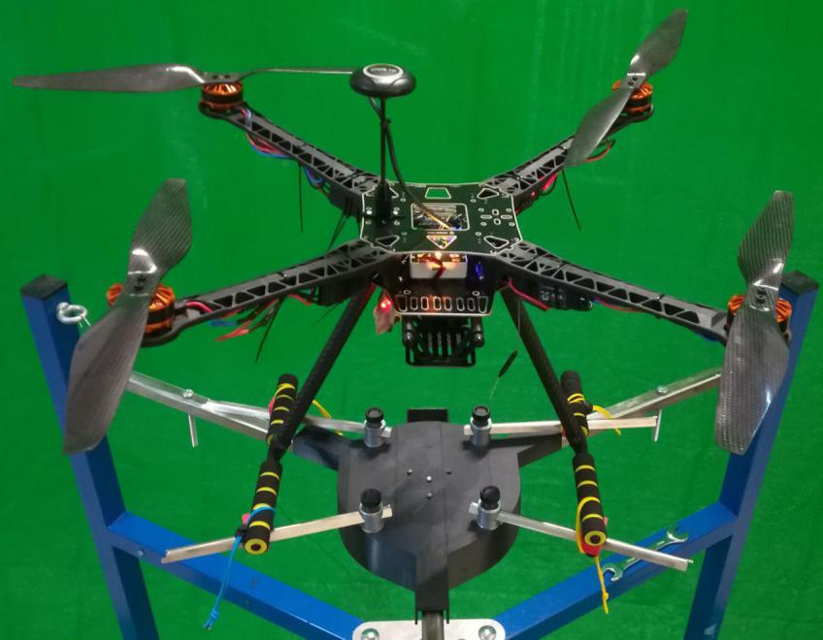

5. Methodology

5.1 Preliminary procedures
The DronesBench model M1 with the RMS tester suitable for the characteristics of the drone being tested is used for the following certificate.
The drone is analyzed in all its parts in order to recognize the components to compile this certificate and to search for any anomalies: uninsulated electrical parts, parts not secured to the structure, correct tightening of the propellers, structure integrity.
First of all the calibration of the DronesBench measuring instrument is verified: the weight measurement with a sample weight and the measurement of the voltage and current by imposing a known absorption.
DronesBench is reset to zero with the RMS tester on the head and then, with power off, the drone rests on the bench's measuring head.
The position of the drone's center of gravity is centered on the base of the bench.
The feet of the drone are secured on the measuring head with the laces supplied, to then feed the drone through the RMS tester with:
- 13.4 V power supply capable of supplying a maximum current of 50 A;
- 11S V 3S battery that provides up to 12.6 V and a maximum current of 54 A.

5.2 Drone test for DronesBench certification
With the engines off, the weight of the drone is measured.
The drone is connected and powered with the supplied cables and the electrical parameters such as voltage, current and power are detected. The absorbed power is recorded as that consumed by the electronics in its basic functions.
Once the stopwatch has been reset, the drone is armed, gradually bringing it to the weight of the throttle, for at least 30 hovering measurements recorded by the software.
The electrical and mechanical parameters are measured with the DronesBench in the moments in which the thrust equals the weight with a tolerance of 10 g.
It is also verified that the drone remains balanced during the thrust increase maneuver.
The motors are then pushed to the maximum for a couple of seconds so that all the measurements are acquired at the moment of maximum current absorption.

5.3 Electromagnetic compatibility tests
As regards the electromagnetic compatibility tests, refer to the directive 2004/108 / EC.
No electromagnetic compatibility tests have been performed.

6. Conclusion
The following data is provided for the license plate and the drone manual:
- Brand and model Kit M1 S600
- Weight 1739 g
- DBIs 92.0 mN/W
- Standard thrust / Weight 203 %
- Max power 580.26 W
- Battery features 3S 11,1V 4400 mAh 30C
- Drone class C2
- Operational area A2
- Maximum transferable kinetic energy 91 J
- Maximum speed 10.25 m/s
- Standard and maximum noise 79,2 dBm 86,4 dBm
The "CE" symbol must be affixed as compatibility has not yet been verified.
The measurements have shown that the drone, characterized by the indicated measurements, is fully functional and ready to fly.
The technician The supervisor

